**EDS**

TEM mode﻿  
slect area﻿  
click on eds icon﻿  
experiment log﻿  
  
STEM mode﻿  
bream setting- Probe - click on MF-Y﻿  
change convergence angle to 10 mmrad(large area to focus)﻿  
increase screen current to 0.4nA﻿  
go to SI﻿  
click on 虚方框﻿  
select an area﻿  
for nanoscale choose 20 microsecond﻿  
  
click on 'drift area'﻿  
  
'object properties' to change some parameters﻿  
  
stop recording﻿  
click on the the right one

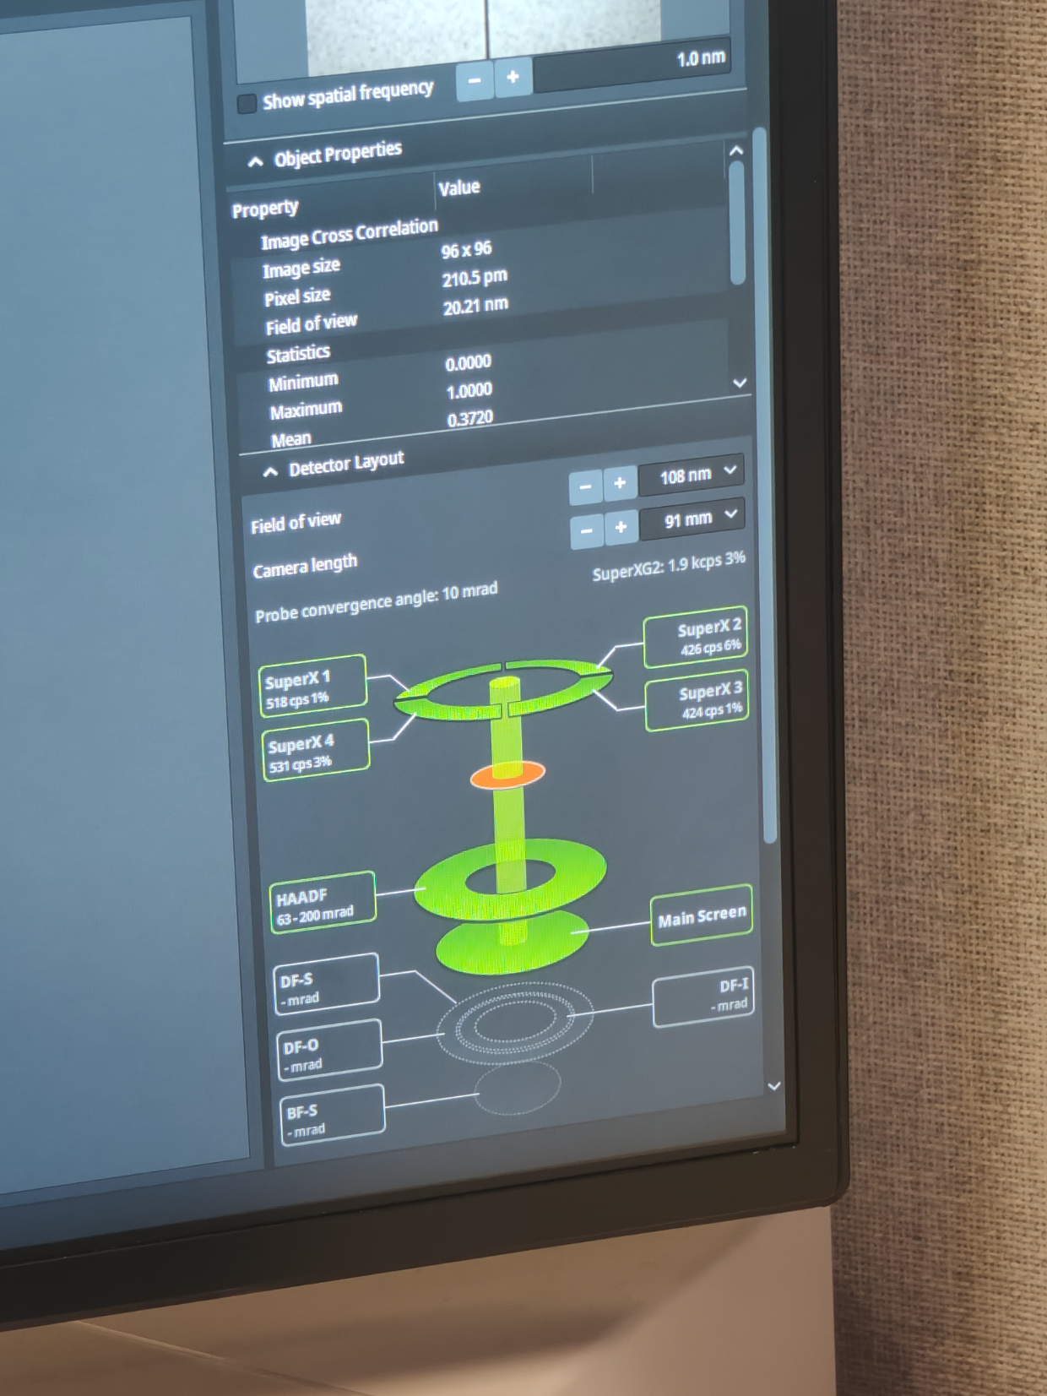

can draw line from 'processing'

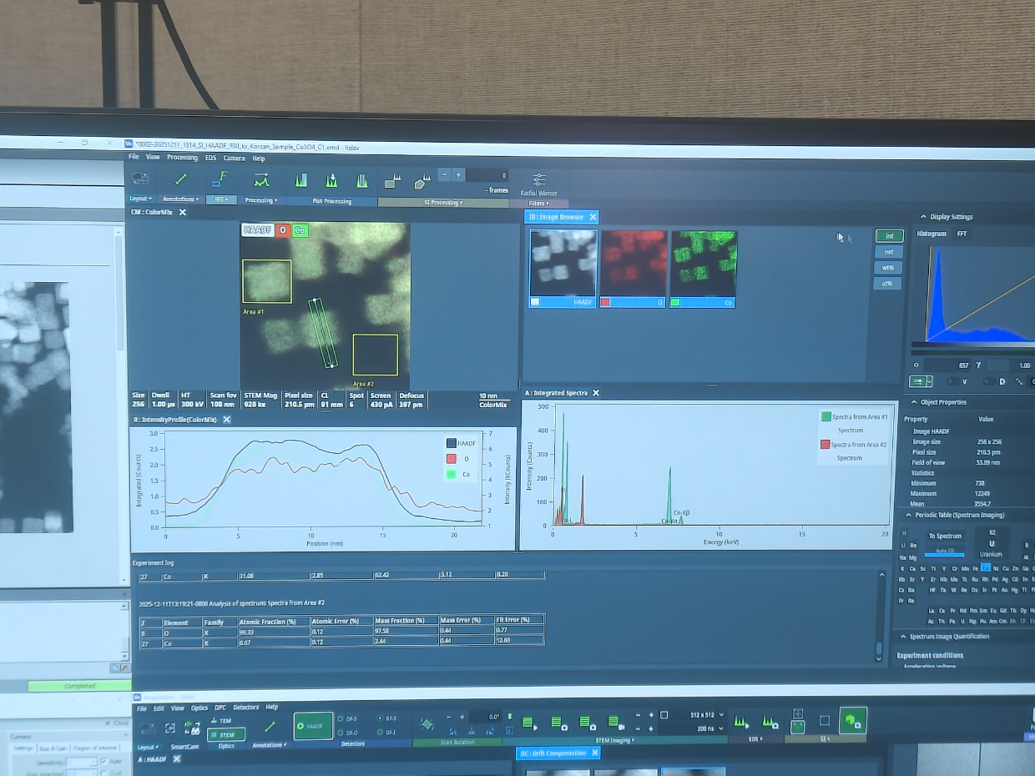

This is another image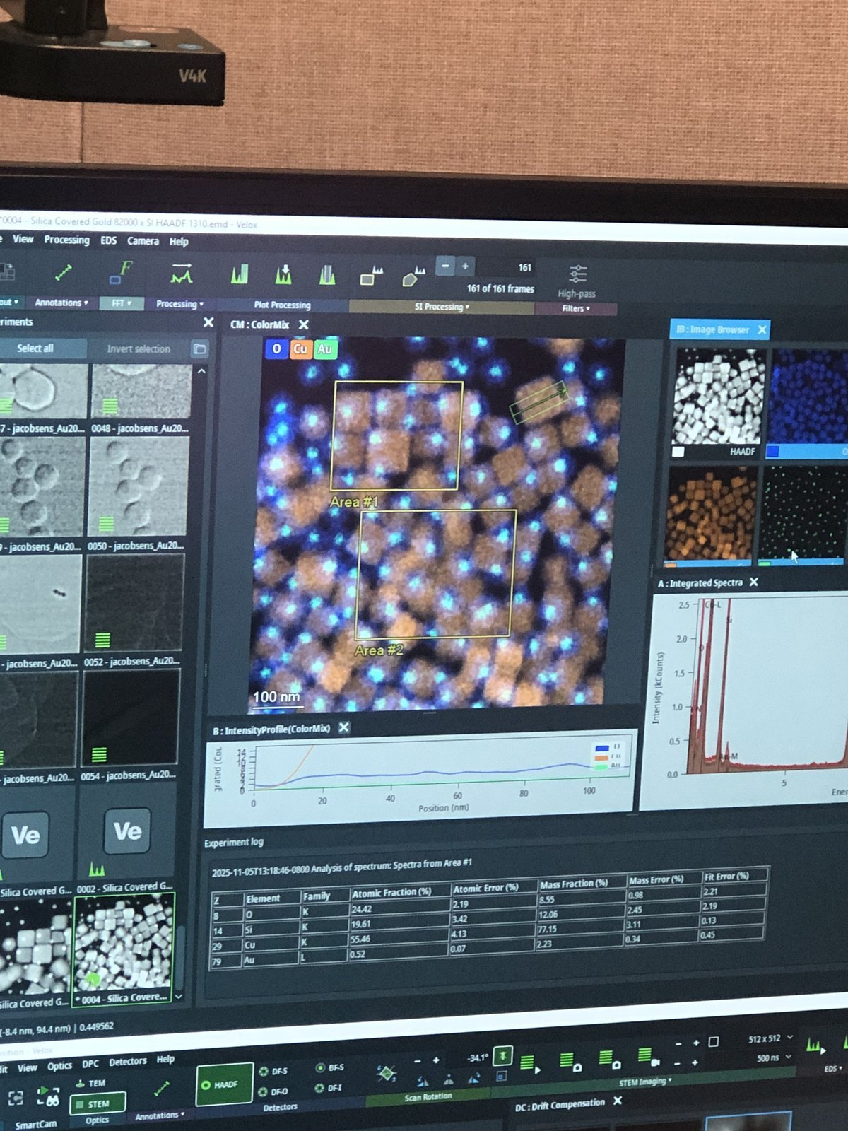

wait until 8 pixel, number come down

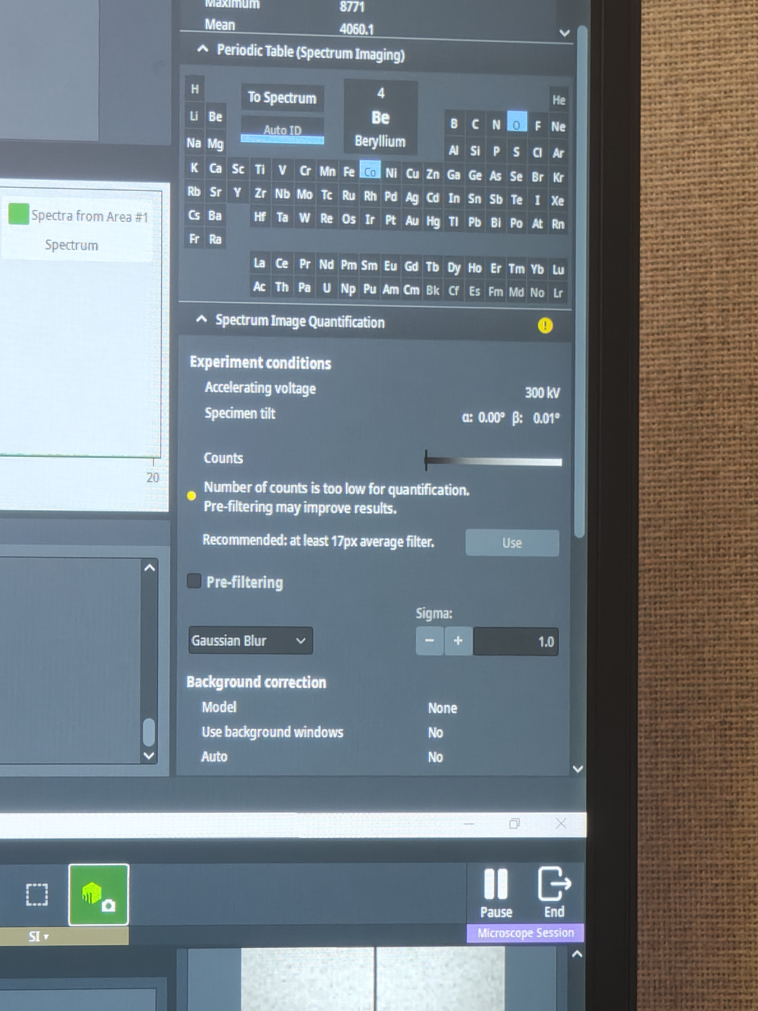

Use average or Gaussian  
Go to EDS, go to ﻿  
can also select an arbitrary area﻿  
for atomic mapping

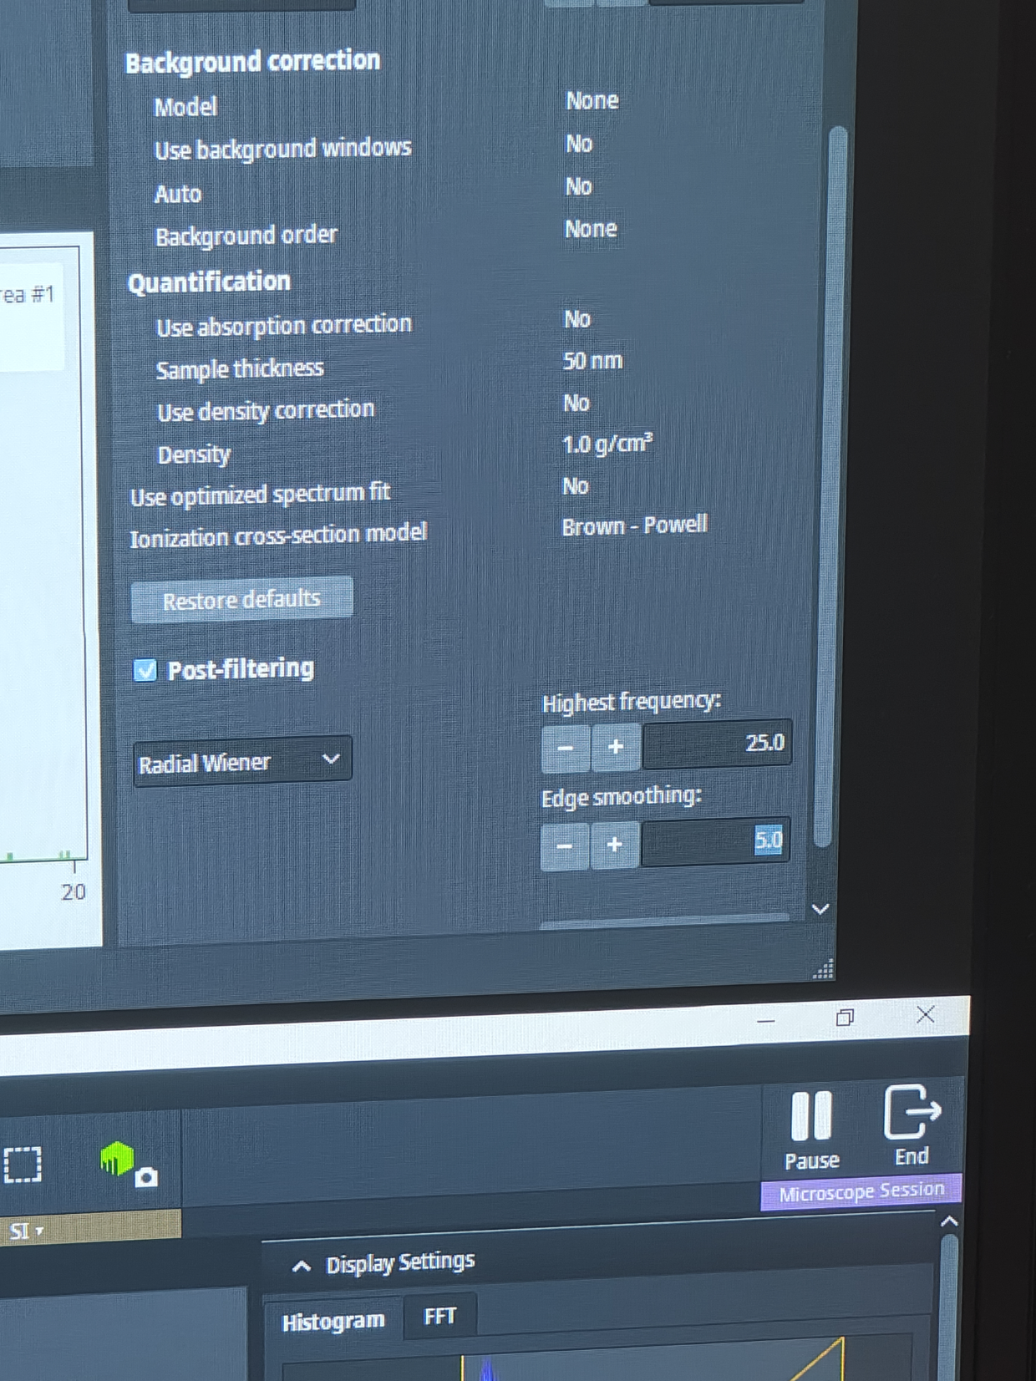

use highest frequency and edges smoothing to obtain atomic resolution